Lab #11 Differential Equations
Adam Jaso
11/22/11
Methods of Solving Differential Equations

Objective
This experiment demonstrates several methods of the solution of first and second order differential equations.

Procedure
The methods used for the first order differential equations are the simple and modified Euler methods and the second and fourth order Runge-Kutta methods. For second order differential equations the modified Euler method was used.

Part I: First Order Differential Equation: 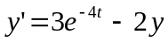
- The Euler method is applied by a script named “euler()” which produces separate plots for the simple and modified methods. The simple Euler method is implemented in “eulersimp(dt)” and the modified Euler method is implemented in “eulermod(dt)”.
  - Eulersimp
    - Define the minimum and maximum t values.
    - Define the initial y and y’ values.
    - Initialize the first values of the recursive loop calculation.
    - Iterate over the minimum to the maximum t value, recursively calculating the next y and y’ values.
    - Plot y vs. t.
  - Eulermod
    - Define the minimum and maximum t values.
    - Define the initial y and y’ values (from the boundary conditions).
    - Initialize the first values of the recursive loop calculation.
    - Iterate over the minimum to the maximum t value, recursively calculating the next y and y’ values.
    - Plot y vs. t.
- The Runge-Kutta method is applied by a script named “runge()” which produces separate plots for the second order and fourth order methods. The second order method is implemented in “runge2(dt)” and the fourth order method is implemented in “runge4(dt)”.
  - Runge2
    - Define the minimum and maximum t values.
    - Initialize the first values of the recursive loop calculation.
    - Calculate the first constants, k1 and k2, of the second order Runge-Kutta calculation.
    - Set the first values of the array of Runge calculated results.
    - Iterate by the step dt from the minimum to the maximum t values, recursively calculating the Runge constants, k1, and k2.
    - Plot y vs. t.
  - Runge4
    - Define the minimum and maximum t values
    - Initialize the first values of the recursive loop calculation.
    - Calculate the first constant, k1, of the fourth order Runge-Kutta calculation.
    - Set the first values of the array of Runge calculated results.
    - Iterate by the step dt from the minimum to the maximum t values, recursively calculating the Runge constants, k1, k2, k3, and k4.
    - Plot y vs. t.

Part II: Second Order Differential Equation: 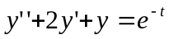
- Define the minimum t and the maximum t.
- Initialize the recursive variables for y, y’, and z’.
- Set the first values of the array of the modified Euler calculated results.
- Iterate by the step dt from the minimum to the maximum t values, recursively calculating the next y, y’, and z’ values from “y(y,yi,ypi)” and “z(h,yi,ypi)” where h is the step size, y is the previous y value, and ypi is the previous y’ value. “zp(t,y,z)” calculates the next z’ value from the previous t, y, and z values.
- Plot y vs. t results of the modified Euler method.

Code / Results
***** EULER.M CODE *****
function []=euler(dt)
%euler.m
%This function finds the numerical solution to the ODE: y' = y^2 + 1

figure(1);
eulersimp(dt);
figure(2);
eulermod(dt);
end

***** EULERSIMP.M CODE *****
function []=eulersimp(dt)
%euler.m
%This function finds the numerical solution to the ODE: y' = 3*e^(-4*t)-2*y

tmin=0;
tmax=5;
%dt=0.01;
t=tmin;
yi=1;
ypi=diffeq(tmin,yi);

ts=tmin;
ys=yi;
while t <= tmax
yi=apx(yi,ypi,dt);
ypi=diffeq(t,yi);
t=t+dt;
ts=[ts t];
ys=[ys yi];
end

plot(ts,ys);
title('Simple Euler');
xlabel('t values');
ylabel('y values');
end

function diffeq=diffeq(t,y)
diffeq=3*exp(-4*t)-2*y;
end

function apx=apx(y,yp,d)
apx=y+d*yp;
end

***** EULERMOD.M CODE *****
function []=eulermod(dt)
%euler.m
%This function finds the numerical solution to the ODE: y' = 3*e^(-4*t)-2*y

tmin=0;
tmax=5;
%dt=0.0005;
t=tmin;
yi=1;
ypi=diffeq(tmin,yi);

ts=tmin;
ys=yi;
while t <= tmax
yi=apx(yi,ypi,dt);
ypi=diffeq(t,yi);
t=t+dt/2;
ts=[ts t];
ys=[ys yi];
end

plot(ts,ys);
title('Modified Euler');
xlabel('t values');
ylabel('y values');

end

function diffeq=diffeq(t,y)
diffeq=3*exp(-4*t)-2*y;
end

function apx=apx(y,yp,d)
apx=y+d/2*yp;
end

***** RUNGE.M CODE *****
function []=runge(dt)
figure(1);
runge2(dt);
figure(2);
runge4(dt);
end

***** RUNGE2.M CODE *****
function []=runge2(dt)
%runge2.m
%This function finds the numerical solution to the ODE: y' = 3*e^(-4*t)-2*y

tmin=0;
tmax=5;
%dt=0.01;
t=0;
ti=0;
yi=1;
k1=dt*diffeq(ti,yi);
k2=dt*diffeq(ti+dt/2,yi+k1);
ts=ti;
ys=yi;

while t < tmax
t=t+dt;
ti=t;
k1=dt*diffeq(ti,yi);
k2=dt*diffeq(ti+dt/2,yi+k1);
yi=yi+k2;

ts=[ts ti];
ys=[ys yi];
end

plot(ts,ys);
title('Runge / Cutta: 2 - point');
xlabel('t values');
ylabel('y values');

end

function diffeq=diffeq(t,y)
diffeq=3*exp(-4*t)-2*y;
end

***** RUNGE4.M CODE *****
function []=runge4(dt)
%runge4.m
%This function finds the numerical solution to the ODE: y' = 3*e^(-4*t)-2*y

tmin=0;
tmax=5;
%dt=0.01;
t=0;
ti=0;
yi=1;
k1=dt*diffeq(ti,yi);
ts=ti;
ys=yi;

while t < tmax
t=t+dt;
ti=t;
k1=dt*diffeq(ti,yi);
k2=dt*diffeq(ti+dt/2,yi+k1/2);
k3=dt*diffeq(ti+dt/2,yi+k2/2);
k4=dt*diffeq(ti+dt,yi+k3);
yi=yi+1/6*k1+1/3*k2+1/3*k3+1/6*k4;

ts=[ts ti];
ys=[ys yi];
end

plot(ts,ys);
title('Runge / Cutta: 4 - point');
xlabel('t values');
ylabel('y values');

end

function diffeq=diffeq(t,y)
diffeq=3*exp(-4*t)-2*y;
end

***** DE2ND.M CODE *****
function []=de2nd(dt,tmin,tmax)

%tmin=0;
%tmax=5;
%dt=0.01;
t=tmin;
yi=1;
zi=2;
zpi=0;

ts=tmin;
ys=yi;

while t <= tmax
yi=y(dt,yi,zi);
zi=z(dt,zi,zpi);
zpi=zp(t,yi,zi);

t=t+dt/2;
ts=[ts t];
ys=[ys yi];
end

plot(ts,ys);
title('Modified Euler 2nd Order');
xlabel('t values');
ylabel('y values');

end

function v=y(h,yi,ypi)
v=yi+h/2*ypi;
end

function v=z(h,zi,zpi)
v=zi+h/2*zpi;
end

function v=zp(t,y,z)
v=-2*z-y+exp(-t);
end

***** EULER.M RESULTS *****
>>euler(.01)
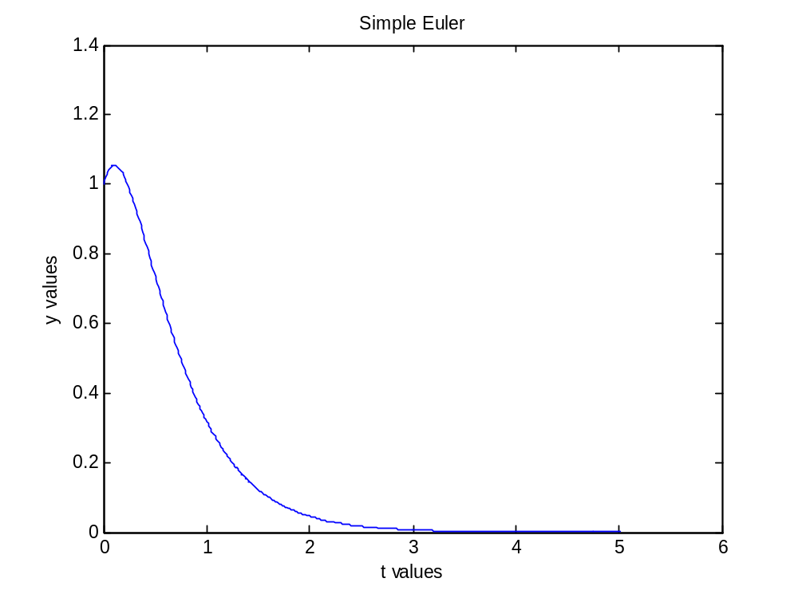
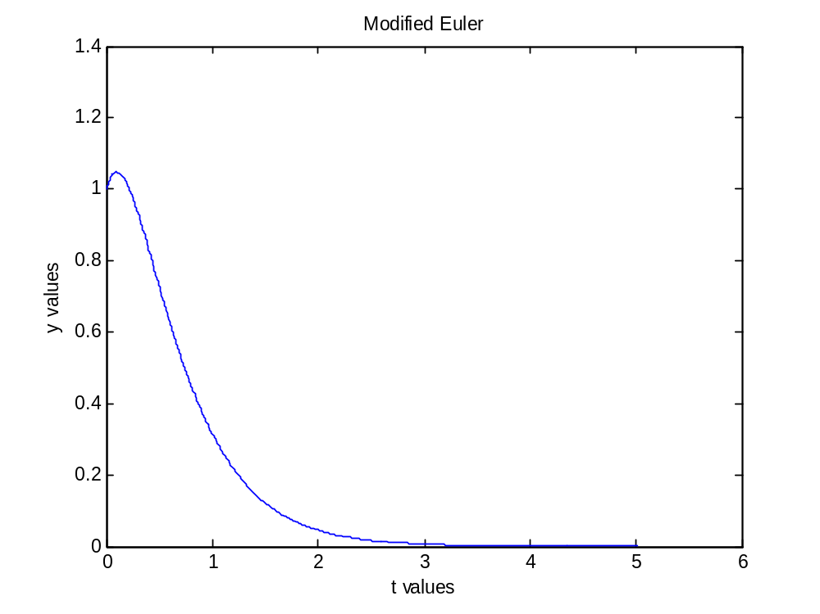
***** RUNGE.M RESULTS *****
>>runge(.001)
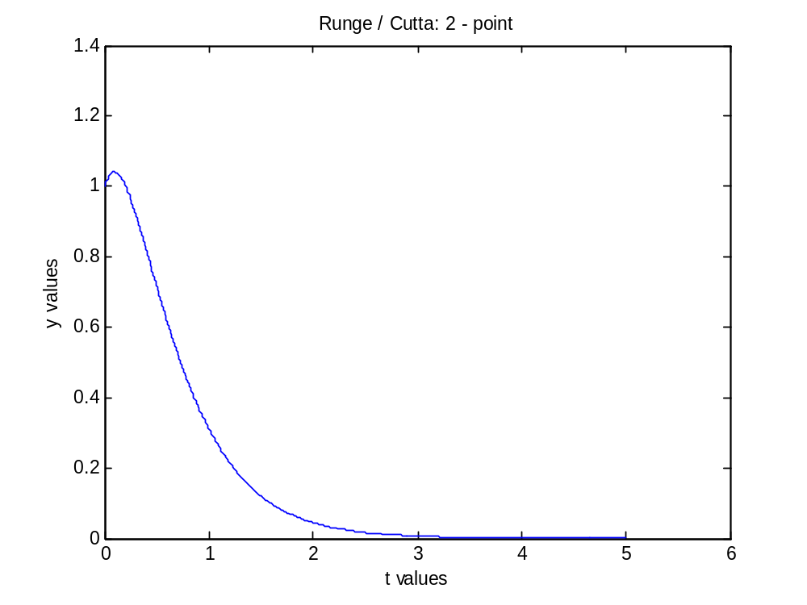
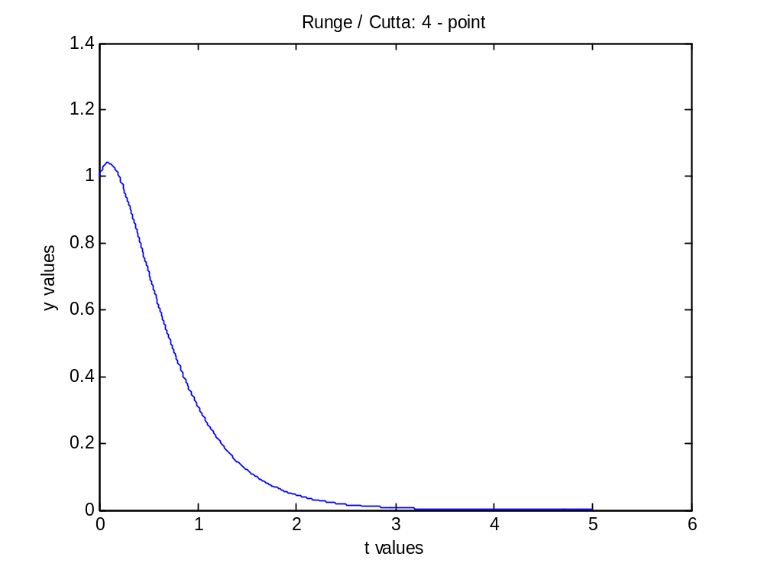
***** DE2ND.M RESULTS *****
>>de2nd(.01,0,5)
